**Course One**

# Foundations of Data Science



# Instructions

Use this PACE strategy document to record decisions and reflections as you work through this end-of-course project. You can use this document as a guide to consider your responses and reflections at different stages of the data analytical process. Additionally, the PACE strategy documents can be used as a resource when working on future projects.

# Course Project Recap

Regardless of which track you have chosen to complete, your goals for this project are:

* Complete the PACE Strategy Document to plan your project while considering your audience members, teammates, key milestones, and overall project goal.
* Create a project proposal for the data team.

# Relevant Interview Questions

Completing this end-of-course project will empower you to respond to the following interview topics:

* As a new member of a data analytics team, what steps could you take to get 'up to speed' with a current project? What steps would you take? Who would you like to meet with?
* How would you plan an analytics project?
* What steps would you take to translate a business question to an analytical solution?
* Why is actively managing data an important part of a data analytics team's responsibilities?
* What are some considerations you might need to be mindful of when reporting results?

**Reference Guide**

This project has three tasks; the following visual identifies how the stages of PACE are incorporated across those tasks.

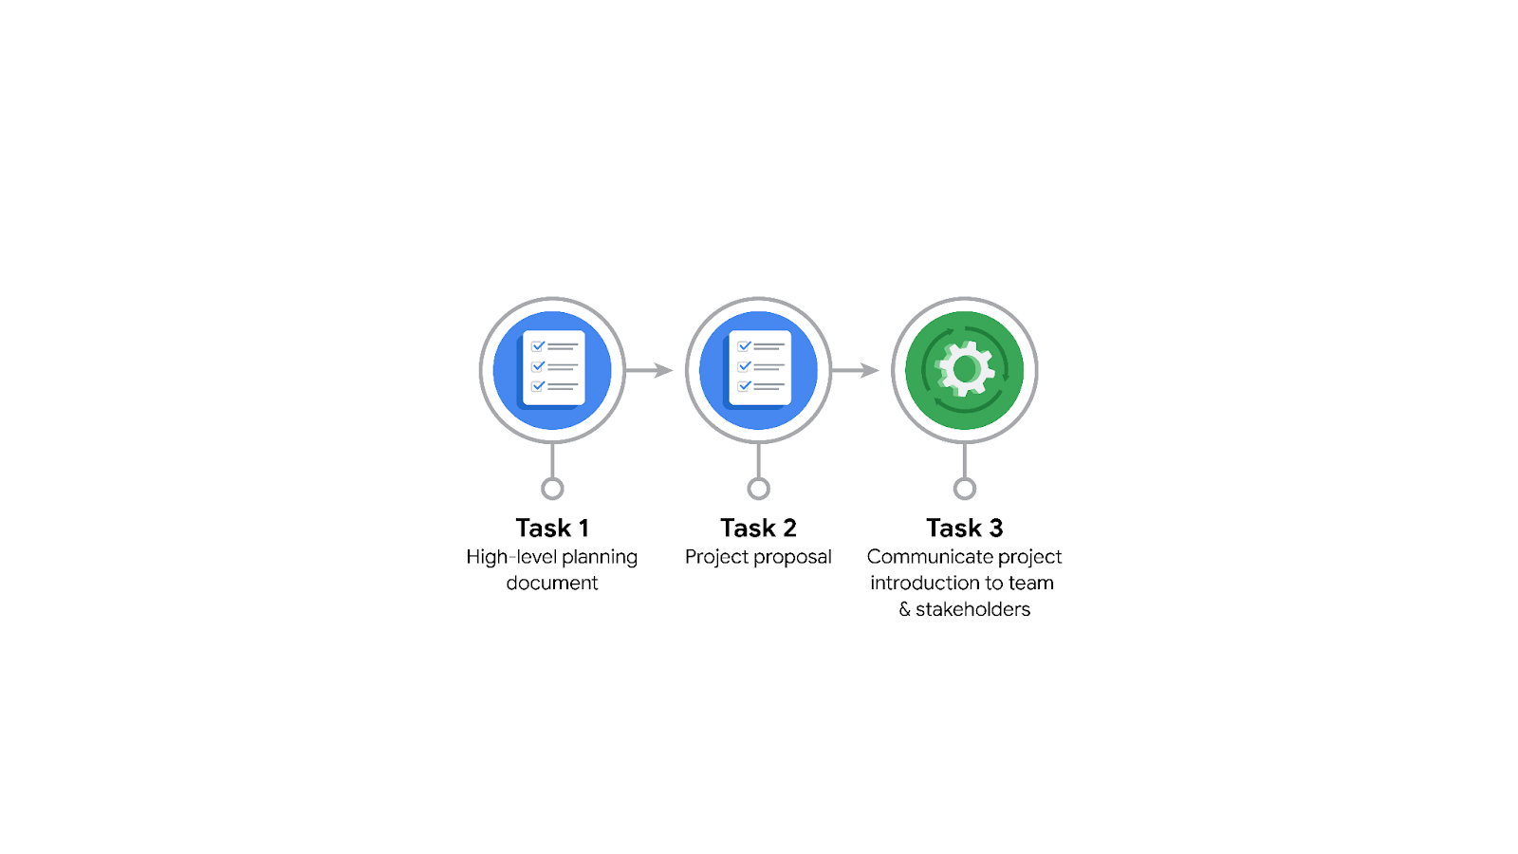

**Data Project Questions & Considerations**

**PACE: Plan Stage**

* Who is your audience for this project?

Users of the TLC app

* What are you trying to solve or accomplish? And, what do you anticipate the impact of this work will be on the larger needs of the client?

To develop a regression model that helps estimate taxi fares before the ride, based on data that TLC has gathered.

This will improve the quality of the clients app , as accurately placed price will be beneficial to both the users of TLC and TLC themselves

* What questions need to be asked or answered?

What is the trade-off between customer satisfaction and profit?

* What resources are required to complete this project?

The data received from TLC

* What are the deliverables that will need to be created over the course of this project?

A regression model for predicting the ride fare , integrated in their app

## 

## **THE PACE WORKFLOW**

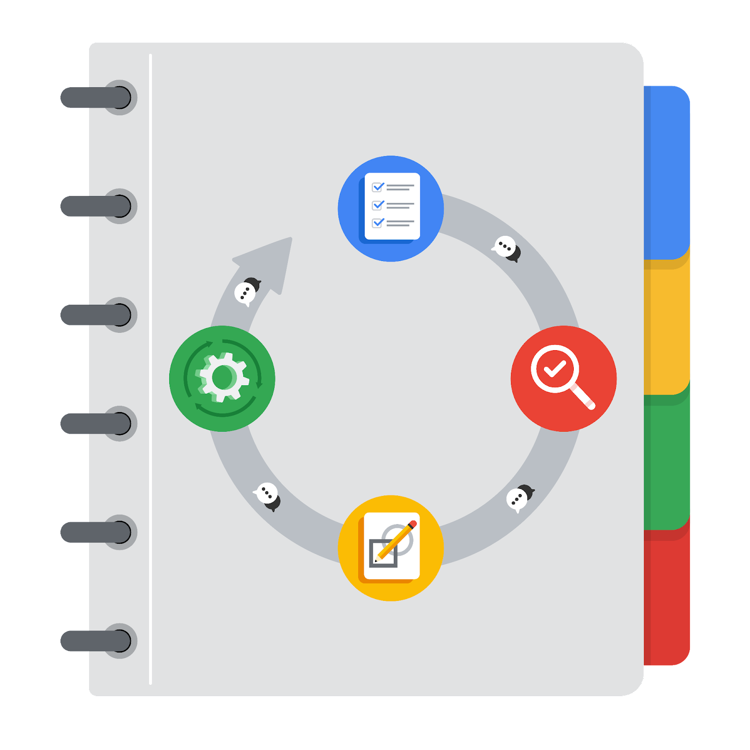

**[Alt-text: The PACE Workflow with the four stages in a circle: plan, analyze, construct, and execute.]**

You have been asked to demonstrate for the company's data team how you would use the PACE workflow to organize and classify tasks for the upcoming project. Select a PACE stage from the dropdown buttons. A few tasks involve more than one stage of the PACE workflow. Additionally, not every workplace scenario will require every task. Refer back to the Course 1 end-of-course portfolio project overview reading if you need more information about the tasks within the project.

### 

### **Project tasks**

Following are a group of tasks your company’s data team has determined need to be completed within this project. The data analysis manager has asked you to organize these tasks in preparation for the project proposal document. First, identify which stage of the PACE workflow each task would best fit under using the drop down menu. Next, give an explanation of why you selected the stage for each task. Review the following readings to help guide your selections and explanation: [The PACE stages](https://www.coursera.org/learn/foundations-of-data-science/supplement/4OtHr/the-pace-stages) and [Communicate objectives with a project proposal](https://www.coursera.org/learn/foundations-of-data-science/supplement/79Ysh/communicate-objectives-with-a-project-proposal). You will later reorder these tasks within a project proposal.

1. **Evaluating the model:** Construct

Why did you select this stage for this task?

Selecting the modelling approach , building models and machine learning algorithms are a part of the Construct phase

1. **Conduct hypothesis testing:** Analyze **and** Construct

Why did you select these stages for this task?

Null hypothesis is set during analyze state and verified at construct phase

1. **Begin exploring the data:** Analyze

Why did you select this stage for this task?

Data exploration is done in this phase

1. **Data exploration and cleaning:** Plan **and** Analyze

Why did you select these stages for this task?

Data exploration and cleaning is done in these phases

1. **Establish structure for project workflow (PACE):** Plan

Why did you select this stage for this task?

Project structure is determined during planning

1. **Communicate final insights with stakeholders:** Execute

Why did you select this stage for this task?

In the execution stage you will present the finding of your analysis, receive feedback, and make revisions as necessary.

1. **Compute descriptive statistics:** Construct

Why did you select this stage for this task?

We will use these correlations to uncover information from the data that would otherwise go unused. These relationships can help our organization make informed decisions about the future.

1. **Visualization building:** Analyze **and** Construct

Why did you select these stages for this task?

The analyzing stage is where we will engage in exploratory data analysis or EDA making visualizations , and it can be carried on to the construct part

1. **Write a project proposal:** Plan

Why did you select this stage for this task?

At the beginning of a project, it is important to establish a solid foundation for success. Here we will define the scope of your project. This is when we will begin by identifying the informational needs of the organization. During the planning stage, we will have the widest viewpoint of a project.

1. **Build a regression model:** Construct **and** Construct

Why did you select this stage for this task?

**J**ust as the name suggests, the construction stage is all about building. In this stage of PACE, we will be building, interpreting, and revising models

1. **Compile summary information about the data:** Execute

Why did you select this stage for this task?

In the execution stage we will present the finding of your analysis, receive feedback, and make revisions as necessary.

1. **Build machine learning model:** Construct

Why did you select this stage for this task?

**J**ust as the name suggests, the construction stage is all about building. In this stage of PACE, we will be building, interpreting, and revising models